**Schedule Management Plan**

**RAMS Corner Ticketing Service System**

**Nacor Industries**

**Street Address**

**APRIL 26, 2023**

**Table of Contents**

Introduction 2

Schedule Management Approach 2

Schedule Control 3

Schedule Changes and Thresholds 3

Scope Change 4

# Introduction

The schedule management plan plays a vital role towards the accomplishment and documentation of each task so that the team may be able to work as efficiently as possible. By going through this section, readers can appreciate the approach of the team to finish their project from scratch along with their milestones done within the timeframe of the project and how the team was able to develop the software and thought process whilst developing the project.

# Schedule Management Approach

Throughout the project’s lifetime, the team is able to submit all deliverables needed. Each work that was assigned to each member has a specific deadline to help the team estimate how many resources will be needed to finish all the needed tasks before proceeding.

To create the project schedule, the team used software named ‘Project Libre’ to create a Gantt Chart. In this Gantt Chart, all the activities and deliverables are listed and recorded. In this way, it is much easier to monitor the project’s growth over time.

See reference below of the start and end date of deliverables for project schedule:

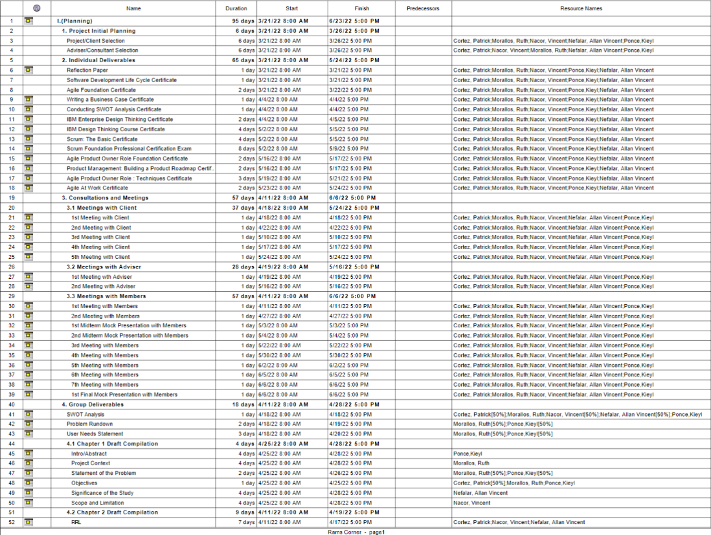

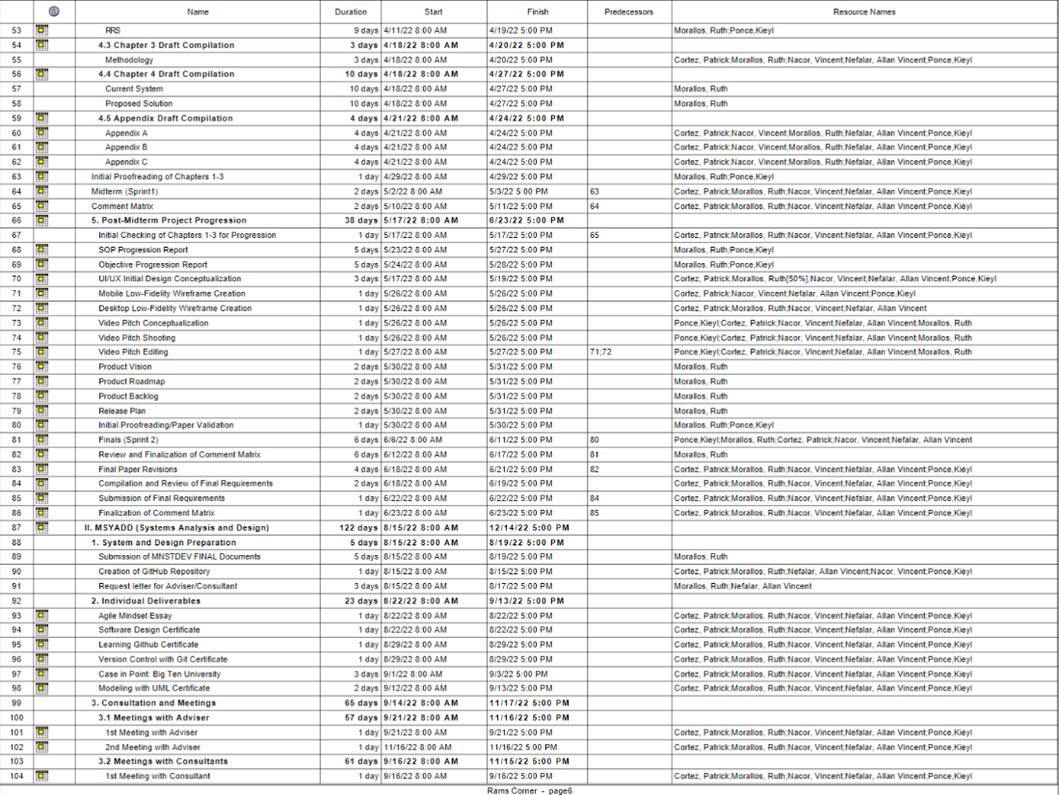

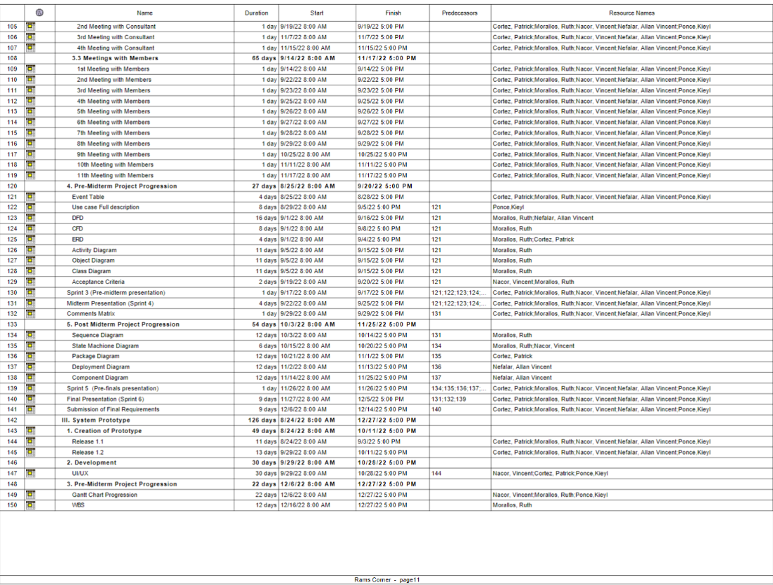

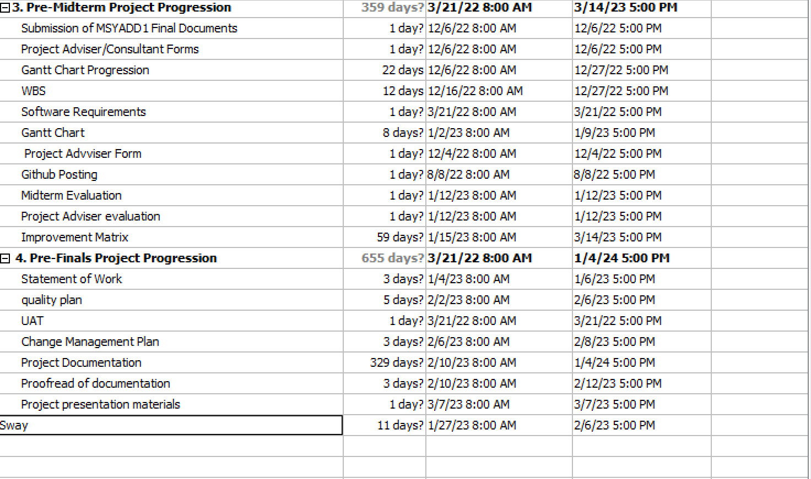

One of the benefits of finishing the activities first is that it may reveal changes that are overlooked and need immediate revisions. In this case, this may slow down the progression of the project. When this happens, the team needs to weigh which changes that can have a significant impact. If changes happen, the project adviser is consulted before implementing the changes. In the roles and responsibilities section, you can determine here the scope of work of the people who are assigned to the roles.

|  |  |
| --- | --- |
| Roles | Responsibilities |
| Project adviser | * + Responsible for guiding the team   + Oversees that the changes and updates are aligned to the scope of work |
| Project leader | * Spearheads the project * Overlooks the documentation and software changes/updates * Approves the changes/updates made within the software and paper under his/her authority |
| Product owner | * Communicates with the project leader and project advisor for product vision * Responsible for making sure that the deliverables are on time and presentable. |
| Scrum master | * Develops the project deliverables * Oversees that the methodology that is used is consistent |
| Scrum member | * Helps the scrum master on the deliverables |

# Schedule Control

Throughout the project lifetime. Updating, deleting, and revising information are bound to happen. Changes within the project are monitored in case the changes are getting slightly off the scope of work. The team would collaborate with the project adviser if the request change were significant to the project.

The project manager will lead the meeting together with the team to discuss the ideas that were added to the equation. The project manager will be managing the schedule of the meetings, updates made within the project, and identifying which tasks are to be done first.

Upon successful compliance, the rest of the team would collaborate to brainstorm and present their ideas since the team’s communication is one of the keys to the success of the project.

# Schedule Changes and Thresholds

When developing a project, it is common to have some delays throughout the duration of the project, when the team feels the project will be delayed and it will require more time to finish. Setting a limit or parameter is important so that in case the project is delayed, less resources are to be used to make up for the loss of time.

If the team requests an extension, the project manager should submit a schedule change request. The person who is responsible for approving the request would be the project sponsor. The project sponsor would review the request and have the power to grant the request under his/her authority.

If the change request is approved. The team would then set up a meeting and begin to thoroughly review and examine the adjustments needed for the project. One of the many factors that affect the schedule is poor management skills. This should be addressed so that it will not happen with other future projects to come.

The product owner, product adviser, and project client must have a meeting and discuss which part of the project will be affected by the potential change. It would then be reviewed to gauge how much resources it would require to be able to finish the project, and most importantly, how it will affect the project scope. It is also important to take note that the project schedule will also be affected by the changes. Finding alternatives is also crucial as it may help to resolve the problems.

# Scope Change

If an issue is overlooked and immediate change is needed. Revising or updating the project scope is the best option there is. Throughout the project's lifetime, changes are inevitable. It is always to be expected that changes might happen from time to time.

**Sponsor Acceptance**

Approved by the Project Sponsor:

Date:

Mr. Jojo Castillo

ITRO Head